1 – project management

**WHAT IS MANAGEMENT?**   
› Planning - deciding what is to be done   
› Organizing - making arrangements   
› Staffing - selecting (the right) people   
› Directing - giving instructions   
› Monitoring - checking on progress   
› Controlling - taking action to remedy delays   
  
**PROBLEMS OF SOFTWARE PROJECTS**   
› Poor estimates and plans   
› Lack of quality standards and measures   
› Poor role definition — who does what?   
› Incorrect success criteria

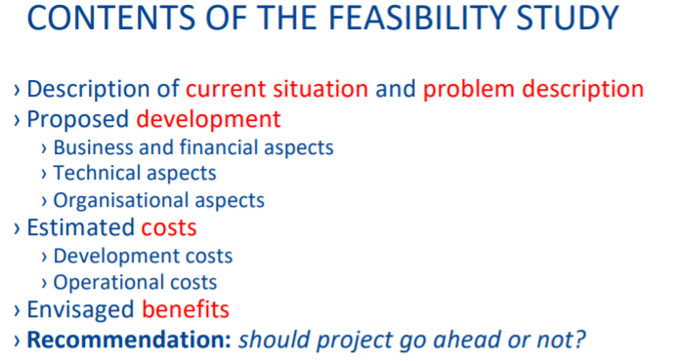**Steps of new project:**  
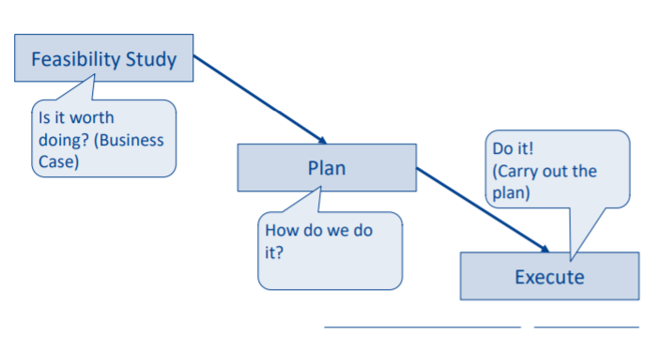

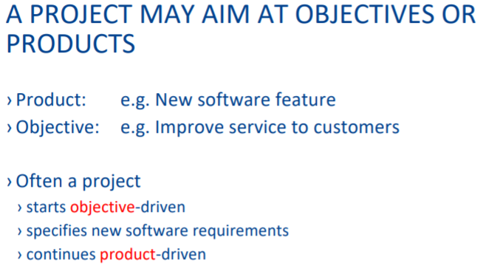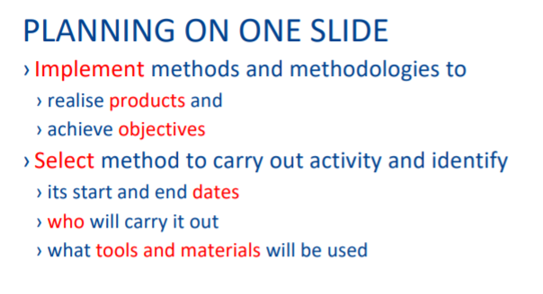

**RISK CATEGORIES**   
**› Project risks**   
› affect project schedule or resources   
› e.g. loss of an experienced designer   
**› Product risks**   
› affect quality and performance of the product   
› e.g. under-performing purchased component   
**› Business risks**   
› affect the organization developing or procuring the product   
› e.g. a competitor introducing a new product

